**TRIS DES COULEURS SELON LES NIVEAUX DE GRIS**

clc

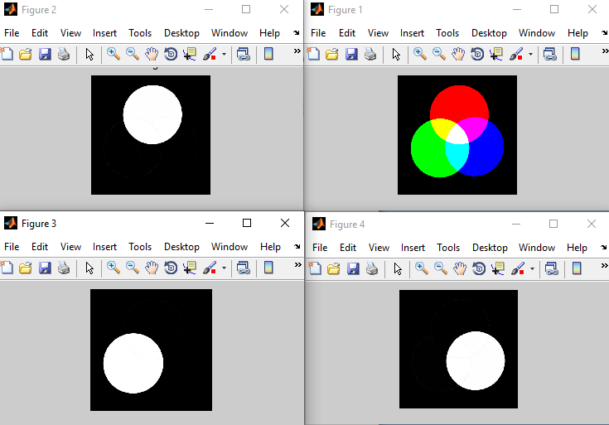

clear all

close all

I=imread('RGB.jpg');

size(I)

R= I(:, :, 1);

G= I(:, :, 2);

B= I(:, :, 3);

figure(1),imshow(I);

figure(2),imshow(R,[0 255]), title('Rouge');

figure(3),imshow(G,[0 255]), title('Vert');

figure(4),imshow(B,[0 255]), title('Bleu');